Home Task 2:
Now vary the packet size and observe the metrics. Take packet size [128,256,512,1024,2048] bytes and collect the throughputs for each of them. Plot the packet size vs Throughput in this case and explain the graph.

Packet size: 128
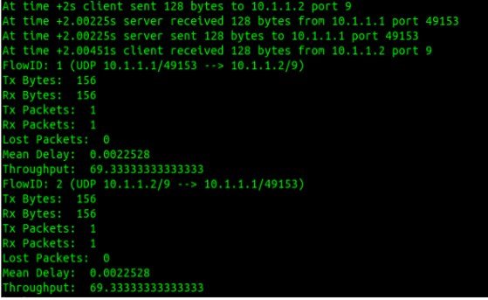

Packet size: 256
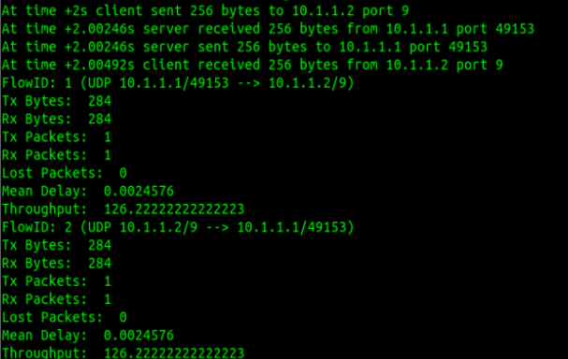

Packet size: 512
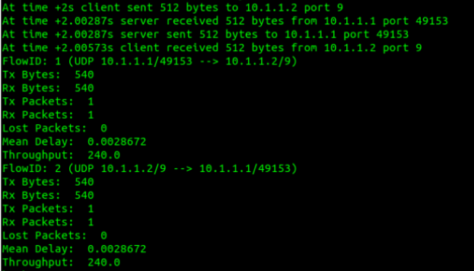

Packet size: 1024
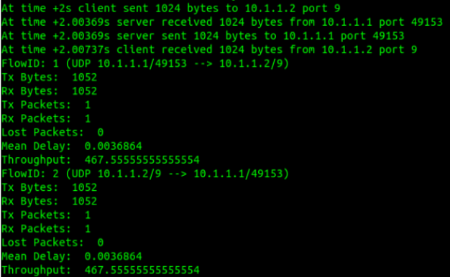

Packet size: 2048
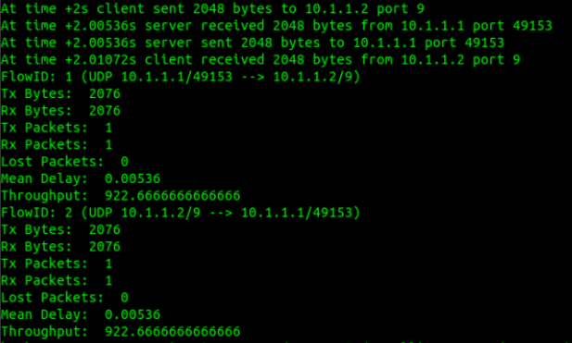

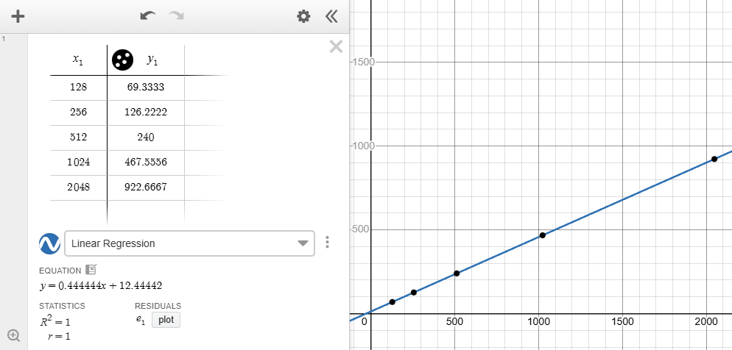
Figure : Packet Size vs Throughput
According to the graph, as packet size increases, throughput increases.
1. Larger packets compared to smaller packets reduce overhead per byte, for smaller packets, most
transmission is spent on headers and acknowledgements.
2. Moreover, with larger packets, less number of packets are to be transferred even with the same
amount of data which minimizes overhead and improves efficiency.

